Contents

Abstract

Acknowledgement

1. Introduction 1
   1. Background of the study----------------------------------------------- 2
   2. Scope of the Corrections/Improvements------------------------------ 3
   3. Statements of the opportunity------------------------------------------ 4
   4. Scope and limitations--------------------------------------------------- 4
      1. Scope----------------------------------------------------------- 4
      2. Limitations----------------------------------------------------- 5
   5. Terminology-------------------------------------------------------------- 5
2. Literature Review------------------------------------------------------------ 6
   1. Introduction-------------------------------------------------------------- 6
   2. History------------------------------------------------------------------- 6-7
   3. Belief--------------------------------------------------------------------- 7-8
   4. Life in Bible Times​—Musicians and Their Instruments----------- 8
   5. Hymn-------------------------------------------------------------------- 9-11
   6. Android-------------------------------------------------------------------- 11
3. Analysis and design------------------------------------------------------- 12-13
4. Implementation and Testing--------------------------------------------- 14-23
5. Conclusion------------------------------------------------------------------- 24
   1. Summary of the research---------------------------------------------- 24
   2. Guidelines for further research---------------------------------------- 25

6. Bibliography----------------------------------------------------------------- 26

**ABSTARCT**

The need of android app for SDA has been satisfied. People followed hymnal book for the reference of hymns. Now it will be available in an android app. It has efficiency and compatibility with android mobile devices. It describes about the history of music and hymns that were sung in the early days of Christianity. People made a joyful noise unto the Lord for his unfailing love and mercy. The development of this app has taken time and effort to give a robust look. It has gone through different phases for development. Planning, analysis, design and implementation. The app has been tested multiple times to bring it into working and usable conditions.

Worship is necessary for every Christian as it bridges the gap between god and humans. Readers will get the idea as to how hymns could be used in the family or in the church. Some parts of this aspect has not been studies. Therefore, I recommend that the features of the app be extended. And bring a vivid information about hymns used in the church.

**ACKNOWLEDGMENTS**

Out of the scores of helpers who have supplied information, suggested sources, given encouragement and constructive criticism, and assisted in various other ways in the preparation of this paper, to select a few for special mention would seem almost invidious. Yet to neglect all would suggest an assumption of competence which is far from the truth. To the several writers on Adventist history who have gone before, particularly M. E. Olsen, Matilda Erickson Andross, and Emma E. Howell, I declare my sincere appreciation for leads and intelligence. Of the friends most responsible for the inception and completion of this project, my thanks are due, first, to Phaneendra Puppala, teacher at Spicer Adventist university, who initiated and made possible the, beginning of the work; Manish Shrestha, who has given every aid and encouragement to it,Reckson Khiangtewho first made the suggestion which eventuated in the enterprise; to Israel Hembrom student of Spicer Adventist University, whose keen but sympathetic criticismhas been a main force; to John D. Snider, manager of the Review and Herald book department; to Edith McClellan, librarian of the Review and Heralds; to LeRoy E. Froom, secretary of the Ministerial Association of the General Conference; to Arthur L. White and D. E. Robinson, of White Publications; to Merwin R. Thurber and H. M. Tippet, book editors, whose steering of the book through the rugged channels of criticism has been admirable; and to T. K. Martin and his associates of the art department, for their zeal and skill in illustration. And I bow my knees in thankfulness to the Father of our Lord Jesus Christ, who’s giving and sustaining of life to the humblest of His creatures is the source and power of all the enterprises of men.

**CHAPTER 1**

**Introduction**

* 1. **Background of the study**

The Scriptures echo with the sound of singing and the hymns echo the theme of the Scriptures. At Creation “the morning stars sang together, and all the sons of God shouted for joy” (Job 30:7): The psalmist declared, “I will sing unto the lord as long as I live: I will sing praise to my God while I have my being” (Ps 104:33). Apostle Paul wanted the members of the church at Colossae to encourage one another in the faith with “psalms and hymns and spiritual songs” (Col. 3:16). The first angel of Revelation 14 asks God’s people to “give glory to him; … and worship him that made heaven, and earth, and the sea, and the fountains of waters” (verse 7).

A hymnal can be used to lead congregation into more creative and significant ways of praising God, a deeper love for Jesus Christ, a keener awareness of the church’s place and mission in the world, a fresh knowledge of God’s will for each life, and a preparation for our Lord’s second coming.

James White recalled that in the early days of the Advent movement in America, “there was…a power in what was called Advent Singing, and such as was felt in no other”. From their beginning, Seventh-Day Adventists have been a singing people. The very first book they published was the 1849 collection of *Hymns for God’s Peculiar People That Keep the Commandments of God and the Faith of Jesus.* James White published five hymnals and four supplements even before the church was formally organized in 1863. White drew freely from the musical heritage of the Methodists, Baptist, and other denomination. He also carried forward some of the “white spirituals” from the *Millennial Harp* of Joshua V. Himes, and added a few new hymns by Adventist authors Uriah, Guard Thy Children” and “Jesus, I My Cross Have Taken” have survived in every hymnal since the first.

A few of the spiritual songs from this early period have been included in the Early Advent section of the hymnal to provide a resource for the celebration of the church’s heritage. While they may not always reach the musical standard of the great hymns of the church, they nevertheless remind us of the fervent faith of our pioneers.

The first “official” *Seventh - day Adventist of God and Faith of Jesus,* issued in 1869.This served until *The Seventh-Day Adventist Hymn and Tune Book (Hymns and Tunes)* was issued in 1886. Even though James White had died in 1881, the influence of his family was still felt in Adventist hymnody. His son J. Edson White set the musical editor, along with Edwin Barnes, expatriate Englishman who served as organist in the denomination’s largest church, the Battle Creek tabernacle.

In 1908 Franklin Belden produced *Christ in Song,* a *“tuneful”* and rhythmic collection much loved by congregations. Indeed, popular demand has led the Church Hymnal Committee to restore some selections from Belden’s hymnal. The next major collection, *The Church hymnal, appeared in 1941.* Professor H.B. Hannum played a major role in that collection. In retirement, he offered encouragement and practical advice that enriched this new hymnal as well.

* 1. **Scope for Corrections/Improvement**

It goes to show that just one negative experience a customer has with your app can seriously trouble or end your relationship with them.

Indeed, it’s important for apps to work well in order to maintain or elevate a consumer’s opinion of an app because a poorly functioning app could sour it.

The findings of a 2015 mobile app user survey conducted by Dimensional Research showed that 80% of app users will only attempt to use a problematic app three times or less and 36% said that an app with slow performance issues made them have a lower opinion of the company.

This app can improve in the following areas: -

1. **User Interface:** The user interface that is provided in this app can be improved to elevate the visual experience.
2. **Audio:** App does not contain any audio of hymnal.
3. **Video:** Add video to every hymnal.
4. Make it compatible with every android device.
5. Add a notepad in the same app so that it could be used while being in the church.
   1. **Statement of the opportunity**  
      Seventh - day Adventist is one of the biggest among the Christian organizations. There are very few android apps available for church. SDA hymnal will contribute to it. The proposed mobile app will have hymns that will allow the user to access in mobile phone than to websites or hymnal book. When the user accesses the app and selects the hymn that he/she want to sing, it will open the lyrics. Before that user must install this app in his mobile phone. He can access the hymn from a simple interface without much of user intervention.

The statement of the opportunity can be coined as, “to develop a usable application for the Android operating system, which can provide the hymns”.

* 1. **Scope and limitations** 
     1. **Scope**

This android based SDA hymnal application automates the hymnal book of the Seventh-Day Adventist Church. The church members can open this app in the church during song service and see the lyrics instead of opening hymn book. The focus of the church member will be more on the song rather than looking for hymn in the hymn book.

* Provide hymns for Christians in an app.
* Know the name of the lyricist of the current hymn.
* Provides most used hymns in the church.
* Provides the complete list of the hymns for the user where the user can select one of them.
  + 1. **Limitations**

1. Audio: This app does not contain any audio of the hymns.
2. Video: There’s no video of hymns.
3. Search: User can’t search for the song listed in the app.
4. Notes: It does not provide musical notes for the hymnal.
   1. **Terminology**

SDA Seventh Day Adventist

Millerites The name refers to belief in the imminent Second Coming (or "Second Advent") of Jesus Christ.

Sabbatarian Christian who strictly observes Sunday as the Sabbath.

Daniel A book in the bible.

Ten Commandments The Ten Commandments are laws or rules handed down to Moses by God on Mount Sinai.

Jesus In a religious context the name refers to Jesus, the central figure of Christianity.

**CHAPTER 2**

**Literature Reviews**

**2.1 Introduction**

In the literature review, the researcher found a good representative literature discussing the Seventh - day Adventist history and the use of hymnal in the church and the need for every Christian to sing the hymns. However, little is written in detail about SDA movements in the history to bridge the shortage of information among Christians. Researcher is grateful to Seventh - day Adventist authors who identified some of the factors that every Christian should know. By studying the relevant literature, it can help understand more fully how other factors play a big role in the SDA mission. (1)

**2.2 History**

The Seventh-day Adventist Church is the largest of several Adventist groups which arose from the Millerites movement of the 1840s in upstate New York, a phase of the Second Great Awakening. William Miller predicted on the basis of Daniel 8:14–16 and the "day-year principle" that Jesus Christ would return to Earth between the spring of 1843 and the spring of 1844.In the summer of 1844, Millerites came to believe that Jesus would return on October 22, 1844, understood to be the biblical Day of Atonement for that year. When this did not happen (an event known as the "Great Disappointment"), most of his followers disbanded and returned to their original churches.

Hiram Edson and other Millerites came to believe that Miller's calculations were correct, but that his interpretation of Daniel 8:14 was flawed as he assumed Christ would come to cleanse the world. These Adventists came to the conviction that Daniel 8:14 foretold Christ's entrance into the Most Holy Place of the heavenly sanctuary rather than his Second Coming. Over the next few decades this understanding of a sanctuary in heaven developed into the doctrine of the investigative judgment, an eschatological process that commenced in 1844, in which every person would be judged to verify their eligibility for salvation and God's justice will be confirmed before the universe. This group of Adventists continued to believe that Christ's Second Coming would continue to be imminent, however they resisted setting further dates for the event, citing Revelation 10:6, "that there should be time no longer."(1)

**2.3 Belief**

Who is God?

God is love, power, and splendor—and God is a mystery. His ways are far beyond us, but He still reaches out to us. God is infinite yet intimate, three yet one, all-knowing yet all-forgiving. We will spend eternity cherishing an ever-deepening relationship with God the Father, Son and Holy Spirit.

Despite the distance sin demands, God has revealed Himself in countless ways. The Bible is the story of God striving to reconnect with His children, and is a major method God uses to reach us. A mosaic of authors, styles and perspectives, the Bible reveals a God who is ever-creative, ever-patient and ever-seeking to restore our relationship with Him. Though written by ordinary people, through the Spirit it pierces our hearts, opens our eyes and convicts us to live for Him.

God the Father reached out to us most dramatically through His Son Jesus, who chose not just to visit us, but to become one of us. Born human so we can be reborn in the Spirit, Jesus showed us God’s love and character—and how far God was willing to go to save us from self-destruction. What we could not do for ourselves, He did for us, paying the price for our sins, dying in our place so we can live forever. He conquered death through resurrection, and promised to return to take us home.

Meanwhile, God has not left us alone. The Holy Spirit is here to comfort us, guide us and transform us to live as witnesses for God’s love. The same Spirit who inspired prophets and empowered Jesus, who shaped scripture and created the world, enables and empowers each one of us. The Spirit activates the “body of Christ,” the church, through spiritual gifts and a humble attitude of service and compassion.(3)

**2.4 Life in Bible Times​—Musicians and Their Instruments**“Praise [God] with the blowing of the horn. Praise him with the stringed instrument and the harp. Praise him with the tambourine and the circle dance. Praise him with strings and the pipe. Praise him with the cymbals of melodious sound. Praise him with the clashing cymbals.”​—PSALM 150:3-5.

Music and musicians have long played a vital role in the worship of Jehovah God. For example, when Jehovah miraculously delivered the Israelites through the Red Sea, Moses’ sister, Miriam, led the women in a victory song and dance. The dancers accompanied themselves with tambourines. This event demonstrates how important music was to the Israelites​—they had just fled from the Egyptian army, yet many of the women had their instruments handy and ready to play. (Exodus 15:20) Later, King David arranged for thousands of musicians to play their instruments as part of worship at the tabernacle. This arrangement continued at the temple built by his son Solomon.​—1 Chronicles 23:5.

**2.5 Hymn**

What is a Hymn?

* Four necessary elements (St. Augustine)
* Wordsof praise**,** to be sung**,** addressing Godpraise, sung,
* Texts that meet most of these criteria:
* Composed
* In the form of poetry
* In strophic form (has regular verses)
* On a religious topic with a religious message
* For singing
* For use in public/private Christian worship
* Addressed to God as the primary audience
* Expressing the thoughts of the singers (praise, prayers, promises, beliefs, or mutual encouragement) (3)

**Hymns in Scripture**

* Original Greek word humnos (umnoß)
* Dictionary Definition “A song in tithe praise of gods, heroes, conquerors; a sacred song”
* “Speak to one another with psalms, hymnsand spiritual songs. Sing and make music in your heart to the Lord, always giving thanks to God the Father for everything, in the name of our Lord Jesus Christ.” (Ephesians 5:19-20)
* “Let the word of Christ dwell in you richly as you teach and admonish one another with all wisdom, and as you sing psalms, hymnsand spiritual songs with gratitude in your hearts to God.” (Colossians 3:16)
* Now at the dedication of the wall of Jerusalem they sought out the Levites from all their places, to bring them to Jerusalem so that they might celebrate the dedication with gladness, with hymns **[**songsNIV]of thanksgiving and with songs to the accompaniment of cymbals, harps and lyres.” (Nehemiah 12:27, NASB)
* “He put a new song in my mouth, a hymnof praise to our God” (King David, director of music Psalm 40:3a)
* “When they had sung a hymn**,** they went out to the Mount of Olives.” (Jesus and His disciples after the Lord’s Supper, Matthew 26:30)
* About midnight Paul and Silas were praying and singing hymnsto God, and the other prisoners were listening to them. Suddenly there was such a violent earthquake that the foundations of the prison were shaken. At once all the prison doors flew open, and everybody's chains came loose.” (Acts 16:25 26)

**Hymns in Church History**

Although Adventist hymnals seem to have a lifetime of about it 25 years, by the early 1980s the existing hymnal had been in service since 1941. The General Conference Music Committee created a diverse 19-member Church Hymnal Committee chaired by C.L. Brooks with Wayne Hooper as secretary. As part of the process more than 3000 Adventist ministers were asked to rate the hymns of the then existing Church Hymnal. Those that were commonly used were retained. Songs that were added to the new hymnal include those of a more diverse and contemporary nature. In 1990 Susan La Rosa Maehre published the complete Adventist Hymnal with organ and piano. "Hymns Alive" is the complete Hymnal available on 33 CD's from PAVE Records. It is recorded with the organ on the right channel and piano on the left.

* “Throughout church history great periods of spiritual fervour and revival have always been accompanied by a renewed interest in congregational singing.” -- Professor Kenneth W. Osbeck
* “Historians have stated that Martin Luther won more converts to Christ through his encouragement of congregational singing than even through his strong preaching and teaching” -- 16th century 16th
* “Of the Wesleys (John & Charles) it was said that, for every person they won with their teaching, ten were won through their music” -- 18th century 18th
* “Singing does at least as much as preaching to impress the Word of God upon people’s minds. Ever since God first called me, the importance of praise expressed in song has grown upon me.” -- D.L. Moody, 19th century19th (4)

**2.6 Android**  
**What is android?**  
Android is a stack of software for mobile devices that are an Operating System, Middleware and Key Application.

Android is a Linux-based operating system which is designed for touchscreen mobile device like smartphones and tablet computers.

**Android Development Tool**

ADT Provides custom XML editors, and debug output pane from which we get the unbelievable enhance during develop the Android applications. Android Developer tool bundle (ADT Bundle) provides:

1. Android SDK Tools
2. Android-Platform-tools
3. The newest Android system image for the emulator.

**CHAPTER 3**

**Analysis and design**

**Requirement Analysis**

Requirements (Hardware and Software):

Hardware:

* RAM-4GB
* Processor-Intel i3 and above
* Hard Disk- 40GB (Minimum)

Software:

* Operating System: Windows 7 & above
* Tools Used: Android SDK
* Coding Language: Java

Analysis

SDA HYMNAL

Get Lyrics

Selects hymns

USER

Fig 3.1

Input Process Output

OUTPUT

PROCESS

INPUT

Checks which button have been selected

Displays lyrics of that hymn

User Screen

Fig 3.2

Design

SDA Hymn

SDA Hymn

LOGO

New Hymn

Hymn 1

Old Hymn

Hymn 2

Index

Hymn 3

Hymn 4

Fig 3.4

**CHAPTER 4**

**Implementation and Testing**

The analysis of the app has been completed earlier in the previous chapter. Here are the implementation of the plan and analysis. Java is used in the development of this application. XML is also used to design the interface.

**activity_main.xml**  
<?xml version="1.0" encoding="utf-8"?>  
<android.support.v4.widget.DrawerLayout xmlns:android="http://schemas.android.com/apk/res/android"  
 xmlns:app="http://schemas.android.com/apk/res-auto"  
 xmlns:tools="http://schemas.android.com/tools"  
 android:layout_width="match_parent"  
 android:layout_height="match_parent"  
 android:id="@+id/drawer"  
 tools:context="com.example.ballackhanSDA.SDAhymnal.MainActivity">  
  
  
 <android.support.design.widget.NavigationView  
 app:headerLayout="@layout/header"  
 android:layout_width="wrap_content"  
 android:layout_height="match_parent"  
 android:background="@color/white"  
 app:itemTextColor="@color/darkgrey"  
 app:itemIconTint="@color/darkgrey"  
 app:menu="@menu/drawermenu"  
 android:layout_gravity="start">  
  
 </android.support.design.widget.NavigationView>  
  
  
 <ScrollView  
 android:layout_width="match_parent"  
 android:layout_height="match_parent">  
  
 <LinearLayout  
 android:layout_width="fill_parent"  
 android:layout_height="wrap_content"  
 android:orientation="vertical">  
  
  
 <Button  
 android:id="@+id/button4"  
 android:layout_width="match_parent"  
 android:layout_height="60dp"  
 android:text="01 BLESSED ASSURANCE" />  
  
 <Button  
 android:id="@+id/button5"  
 android:layout_width="match_parent"  
 android:layout_height="60dp"  
 android:text="02 MY MAKER AND MY KING" />  
  
 <Button  
 android:id="@+id/button6"  
 android:layout_width="match_parent"  
 android:layout_height="60dp"  
 android:text="03 Praise to the Lord" />  
  
 <Button  
 android:id="@+id/button7"  
 android:layout_width="match_parent"  
 android:layout_height="60dp"  
 android:text="04 All Creatures of Our God and King" />  
  
 <Button  
 android:id="@+id/button8"  
 android:layout_width="match_parent"  
 android:layout_height="60dp"  
 android:text="05 God Himself Is With Us" />  
  
 <Button  
 android:id="@+id/button9"  
 android:layout_width="match_parent"  
 android:layout_height="60dp"  
 android:text="06 Praise, My Soul, the King of Heaven" />  
  
 <Button  
 android:id="@+id/button10"  
 android:layout_width="match_parent"  
 android:layout_height="60dp"  
 android:text="07 All My Hope on God Is Founded" />  
  
 <Button  
 android:id="@+id/button11"  
 android:layout_width="match_parent"  
 android:layout_height="60dp"  
 android:text="08 O Worship the Lord" />  
  
 <Button  
 android:id="@+id/button12"  
 android:layout_width="match_parent"  
 android:layout_height="60dp"  
 android: text="09 We Gather Together" />  
  
 <Button  
 android:id="@+id/button13"  
 android:layout_width="match_parent"  
 android:layout_height="60dp"  
 android:text="10 The Lord in Zion Reigneth" />  
  
 <Button  
 android:id="@+id/button14"  
 android:layout_width="match_parent"  
 android:layout_height="60dp"  
 android:text="11 Let All the World in Every Corner Sing" />  
  
 <Button  
 android:id="@+id/button15"  
 android:layout_width="match_parent"  
 android:layout_height="60dp"  
 android:text="12 Come, Christians, Join to Sing" />  
  
 <Button  
 android:id="@+id/button16"  
 android:layout_width="match_parent"  
 android:layout_height="60dp"  
 android:text="13 The God of Abraham Praise" />  
  
 </LinearLayout>  
 </ScrollView>  
</android.support.v4.widget.DrawerLayout>

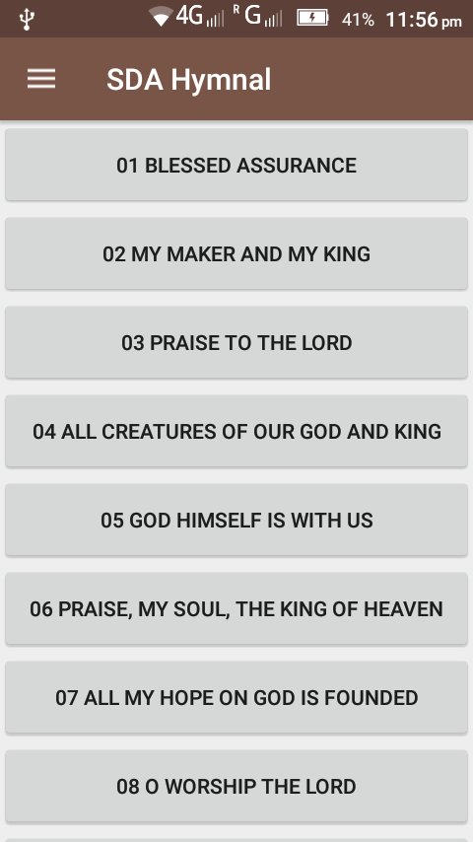

**drawermenu.xml**

<?xml version="1.0" encoding="utf-8"?>  
<menu xmlns:android="http://schemas.android.com/apk/res/android">  
 <group>  
 <item android:id="@+id/nh" android:title="New Hymnal" android:icon="@drawable/ic_2"/>  
 <item android:id="@+id/oh" android:title="Old Hymnal" android:icon="@drawable/ic_book_font_awesome_svg"/>  
 <item android:id="@+id/fb" android:title="Favourite" android:icon="@drawable/ic_favourite512x512"/>  
 <item android:id="@+id/ti" android:title="Topical Index" android:icon="@drawable/ic_iindex"/>  
 <item android:id="@+id/fe" android:title="Featured" android:icon="@drawable/ic_business_survey_icon"/>  
 </group>  
 <item android:id="@+id/set" android:title="Settings" android:icon="@drawable/ic_setting"/>  
  
</menu>

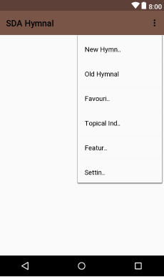

**header.xml**

<?xml version="1.0" encoding="utf-8"?>  
<LinearLayout  
 xmlns:android="http://schemas.android.com/apk/res/android"  
 android:orientation="vertical"  
 android:layout_width="match_parent"  
 android:layout_height="160dp"  
 android:background="@drawable/bible"  
 android:padding="20dp">  
 <ImageView  
 android:src="@drawable/logo"  
 android:layout_width="100dp"  
 android:layout_height="75dp"/>  
 <TextView  
 android:layout_width="wrap_content"  
 android:layout_height="wrap_content"  
 android:text="SDA Hymnal"  
 android:textStyle="bold"  
 android:textSize="20dp"/>  
  
  
</LinearLayout>

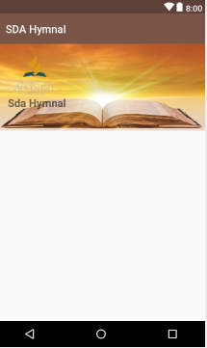

**Activity_main.java**

package com.example.ballackhanSDA.SDAhymnal;  
  
import android.content.Intent;  
import android.support.v7.app.ActionBarDrawerToggle;  
import android.support.v4.widget.DrawerLayout;  
import android.support.v7.app.AppCompatActivity;  
import android.os.Bundle;  
import android.view.MenuItem;  
import android.view.View;  
import android.widget.Button;  
  
public class MainActivity extends AppCompatActivity {  
 public DrawerLayout mDrawerlayout;  
 public ActionBarDrawerToggle mToggle;  
 Button b1, b2,b3,b4;  
  
 @Override  
 protected void onCreate(Bundle savedInstanceState) {  
 super.onCreate(savedInstanceState);  
 setContentView(R.layout.activity_main);  
 b1=(Button)findViewById(R.id.button4);  
 b1.setOnClickListener(new View.OnClickListener() {  
 @Override  
 public void onClick(View view) {  
 Intent intent= new Intent(MainActivity.this, Main2Activity.class);  
 startActivity(intent);  
  
 }  
 });  
 b2=(Button)findViewById(R.id.button5);  
 b2.setOnClickListener(new View.OnClickListener() {  
 @Override  
 public void onClick(View view) {  
 Intent intent= new Intent(MainActivity.this, Main3Activity.class);  
 startActivity(intent);  
  
 }  
 });  
 b3=(Button)findViewById(R.id.button6);  
 b3.setOnClickListener(new View.OnClickListener() {  
 @Override  
 public void onClick(View view) {  
 Intent intent= new Intent(MainActivity.this, Main4Activity.class);  
 startActivity(intent);  
  
 }  
 });  
 b4=(Button)findViewById(R.id.button7);  
 b4.setOnClickListener(new View.OnClickListener() {  
 @Override  
 public void onClick(View view) {  
 Intent intent= new Intent(MainActivity.this, Main5Activity.class);  
 startActivity(intent);  
  
 }  
 });  
 mDrawerlayout=(DrawerLayout)findViewById(R.id.drawer);  
 mToggle = new ActionBarDrawerToggle(this,mDrawerlayout,R.string.open,R.string.close);  
 mToggle.syncState();  
 getSupportActionBar().setDisplayHomeAsUpEnabled(true);  
  
 }  
  
 @Override  
 public boolean onOptionsItemSelected(MenuItem item) {  
 if(mToggle.onOptionsItemSelected(item)) {  
 return true;  
 }  
 return super.onOptionsItemSelected(item);  
 }  
}

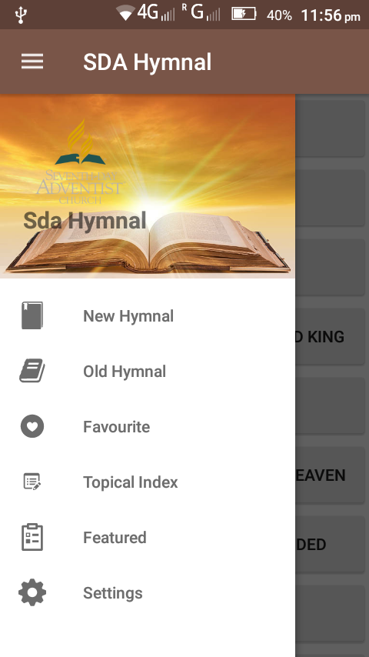

Testing

The app opens smoothly on the mobile device. It has been tested in android 6.0 marshmallow version. On clicking on of the toggle button it opens up the drawer menu. This is the output of a button when clicked displays the song in the next activity. The font size also matches with that declared in the code. There is also the menu item under the navigation drawer which opens up on clicking of the toggle button.

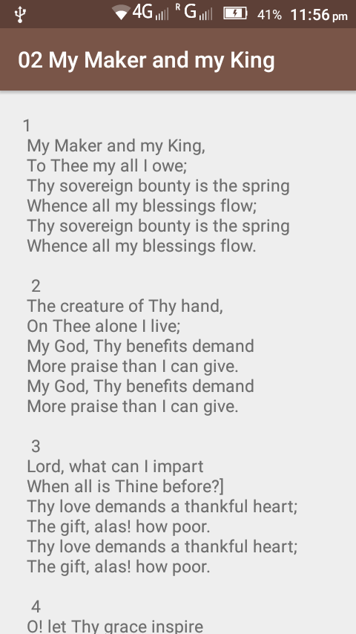

**CHAPTER 5**

**Conclusion**

People in the bible have worshipped and adore their God with all the possible music and instruments. Hymnal should be a part of every Christian lives as it sooths and relaxes soul and our heart. These hymns should be in fingertips so that anyone can access anywhere. For this cause SDA hymnal in android is a much more diverse app than iOS and Windows app. Seventh - day Adventist organization also could develop android apps to reach every believer far and wide. It's because Android doesn't release one application from one person with one app every year, but countless apps from numerous people, adding their own twist, throughout the year, developing app gradually day-by-day. I am not one to say that SDA hymnal is better or worse than other apps, but is unique and incomparable to other mobile application.

**5.1 Summary of the research**  
Android is the open source operating system. Therefore, anyone can develop apps and distribute it. Hymnal developed by me contains hymns that are used in the church. It provides lyrics for every hymn present in the app.

The interface is user-friendly and the app could be installed in android mobiles. There are few things that couldn’t be done due to shortage of time. The interface could be improved and the items in navigation drawer has to be implemented. This would complete the app.

**5.2 Guidelines for further Research**

In my research I have tried to bring how the music started in the bible history. People played music and danced when they were cheerful. It also pointed out that God Wants us to be in harmony with him by singing hymn and praise. This hymnal app contains hymns that are sung by the Christian.

The following is a compilation of recommendations for further research:

* The original music/track should be available to the user.
* Analyze how hymnal affects a Christian life.
* Images that are related to the lyric should be used as background images.
* Analyze the risk of changing the lyrics by individuals.
* Categorizing the hymns into groups.

**CHAPTER 6  
Bibliography**

1. https://www.adventist.org
2. https://books.google.co.in/books?id=VJUBoFYC21QC&pg=PP9&lpg=PP9&dq=introduction+of+SDA+hymnal&source=bl&ots=JYRbHn5y-R&sig=vBqA4BL1YU04H4_mpXZBSvDiHTg&hl=en&sa=X&ved=0ahUKEwipiMHvp8jZAhUBu48KHVdKBKUQ6AEIiAEwCQ#v=onepage&q&f=alse
3. https://en.wikipedia.org/wiki/Seventh-day_Adventist_Church
4. http://thinkapps.com/blog/post-launch/mobile-app-performance-tips/
5. https://www.google.co.in/search?q=conclusion+of+android+application&oq=conclusion+of+android+app&aqs=chrome.0.0j69i57j0l3.8283j0j7&sourceid=chrome&ie=UTF-8
6. https://wol.jw.org/en/wol/d/r1/lp-e/2012089
7. Blake Dowson 2008- Published by Blake Dowson
8. Android by Prasanna Kumar Dixit